[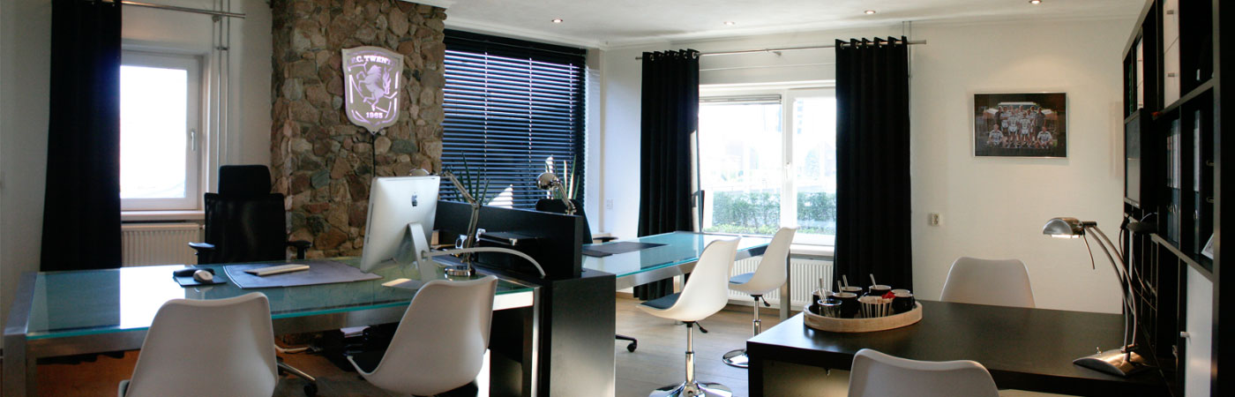](https://www.rkwstudio.nl/over-ons)